USPS Employee Assistance Program (EAP)
Suicide Awareness and Prevention Campaign

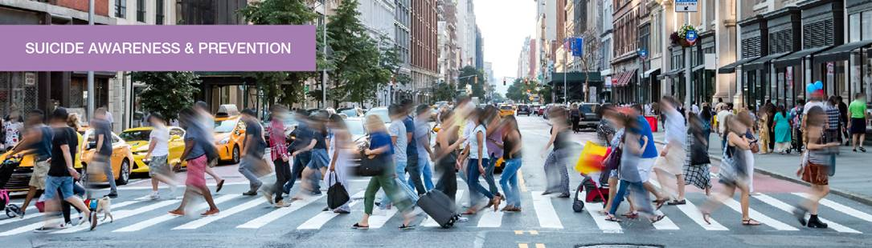

Suicide is a serious, far-reaching public health problem that causes serious emotional, physical and economic impacts. Together we can take action to help break the silence and stigma surrounding mental health challenges and extend support to those in need. September is National Suicide Prevention Month and we’d like to remind everyone of the EAP’s goal to ensure that postal employees and those they care about have access to the resources they need to discuss suicide prevention and to seek help. The Suicide Awareness and Prevention campaign encourages individuals to seek support early, share information about available resources and foster an environment where talking about mental health and suicide is normalized, which can help those struggling feel less isolated and more likely to reach out for support. The campaign also includes strategies for how to support others who may be struggling by taking action and offering aid.

Click here to find facts, see statistics and learn more about suicide from the Centers for Disease Control and Prevention (CDC).

. . . . .

EAP has created (and attached) the following resources as part of the 2024 Suicide Awareness and Prevention campaign to promote awareness, suggest ways to discuss suicide in a supportive fashion and to provide guidance for those at risk and others around them.

Identifying warning signs of suicidal thoughts is critical to providing timely help and support:

- Know the Signs of Suicide
- Warning Signs in Teens
- Recognizing Signs in You

Open conversations about mental health and emotional struggles reduce stigma:

- We Should Talk About It
- Know the Right Words to Say

Recognizing that our service members and veterans are at special risk:

- Resources for Veterans and Military Members

Approaching someone who may be struggling with suicidal thoughts requires sensitivity and care. Learn how to offer support to those at risk:

- Know What to Do
- You Can Make a Difference
- How to Help Yourself
- The 988 Suicide and Crisis Lifeline

Losing someone to suicide can be intense and overwhelming:

- Losing Someone Close

Hope, resilience and supportive communities all play a crucial role in protecting and preventing against suicidal thoughts and behaviors:

- How to Cultivate Hope
- How to Build Resilience
- Prevention Through Connection
- Stories of Hope and Recovery

The campaign materials are also available for download on our Campaign and Monthly Focus pages through the month of September along with a narrated Suicide Awareness and Prevention presentation.

In addition to the campaign handouts and presentation, the EAP has designed a Service Talk (attached) to support EAP field staff.

. . . . .

Suicide Awareness and Prevention Month is the perfect time to remind employees of the additional prevention information on EAP4YOU.com as well as the tips, articles, risk assessment and webinars available in our Health Resource Library.

Employees can quickly access the EAP site and employee assistance resources by scanning the QR code below. The code connects smartphone users directly to EAP4YOU.com where visitors will find comprehensive information about EAP products and services. For more information or help downloading the app to your phone give the EAP a call: 800-327-4968.

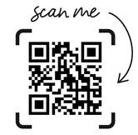

. . . . .

September is also a good time to spread awareness and share additional resources. In addition to the USPS Employee Assistance Program, the following organizations can help educate and protect those struggling with suicidal thoughts:

- 988 Suicide & Crisis Lifeline: The 988 Lifeline is a national network of local crisis centers that provides 24/7, free and confidential emotional support for people in suicidal crisis or emotional distress. They are committed to improving crisis services and advancing suicide prevention by empowering individuals, advancing professional best practices and building awareness. Visit https://988lifeline.org/ to learn more.

- Centers for Disease Control and Prevention (CDC): Visit the CDC’s Suicide Resources page to find additional suicide prevention resources, publications and data sources.

- National Institute of Mental Health (NIMH): The NIMH also has an abundance of information on suicide, prevention and options available for people at risk.

- The Veterans Crisis Line: Dial 988, then press 1 | Text 838255 | Or visit the Veterans Crisis Line website for more information and guidance.

. . . . .

The USPS Employee Assistance Program aims to contribute to a world where seeking mental health aid is met with compassion and understanding. Join our mission to create a more informed, compassionate, and proactive workplace that can effectively support those at risk and ultimately reduce suicide. The EAP has the tools and resources available to help face obstacles head on, with greater success. As always, reach out for additional information and further support:

EAP4YOU.com | 800-327-4968 (800-EAP-4YOU) | TTY: 877-492-7341

